Reaction Rush is a fast-paced, reflex-testing game where the goal is to respond as quickly as possible to a series of flashing LEDs. Eight LEDs are arranged in a line, and at random intervals, one or more of these LEDs will light up. The player must press the corresponding button for each lit LED before time runs out.

Reaction Rush offers two modes: Easy Mode and Hard Mode. In Easy Mode, the LEDs light up at a slower pace, and the time allowed for the player to respond is more generous, making it accessible for beginners or those looking to practice their reflexes. Hard Mode increases the challenge by speeding up the intervals at which the LEDs light up and reducing the time allowed to press the correct buttons, providing a more intense and competitive experience.

As the game progresses, the LEDs will light up more frequently, challenging the player to react faster and with greater accuracy. If the player successfully presses the correct buttons within the allotted time, they will continue to play, with their score increasing based on their speed and precision. However, if the player presses an incorrect button or fails to respond in time, the game ends with a score of 0, and a short tune signals their loss.

If the player manages to respond correctly to all the LEDs, a victory tune plays, and their final score is displayed. The quicker and more accurate the player, the higher the score they will achieve. Reaction Rush is a test of both speed and accuracy, offering players a chance to challenge themselves and improve their reaction times, with varying levels of difficulty to suit all skill levels.

Rough Idea

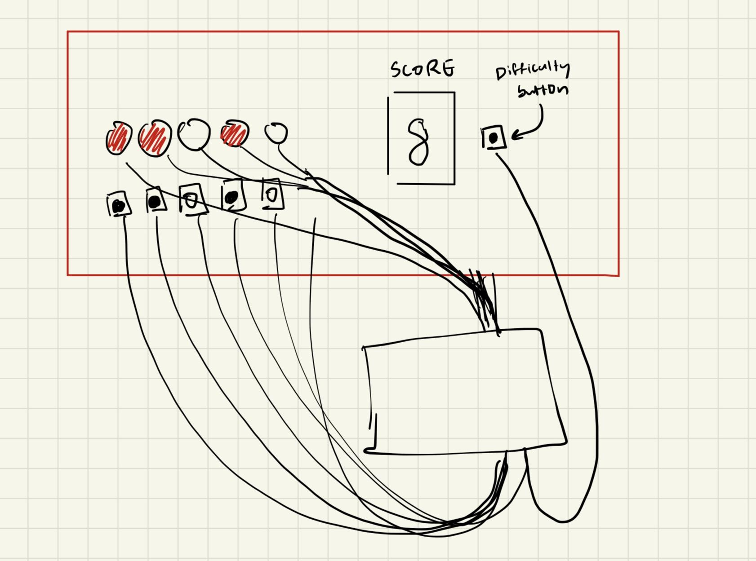

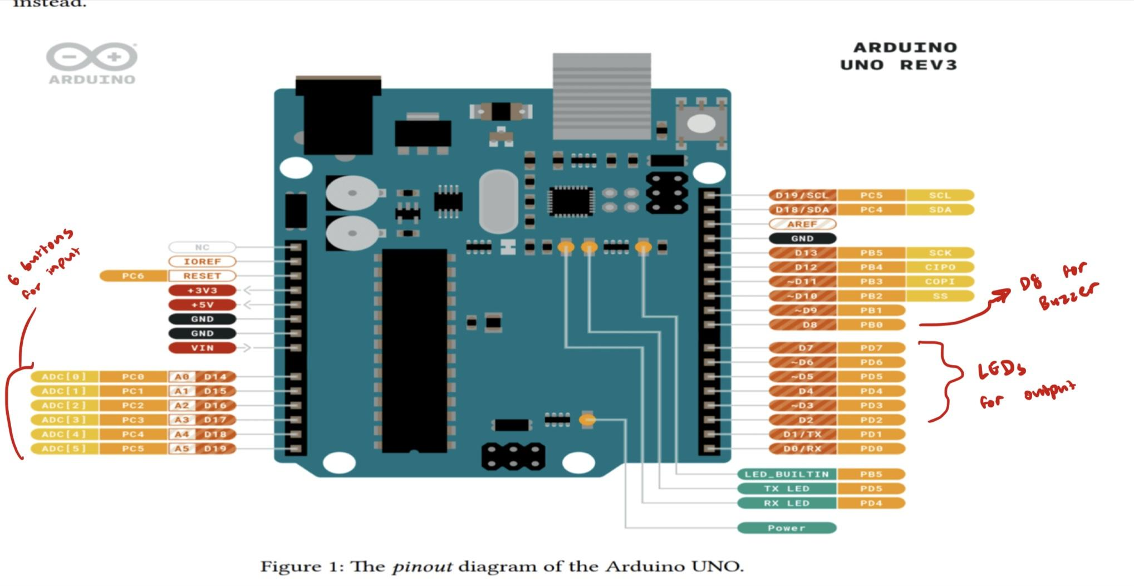

Microcontroller:

Elegoo UNO R3 Microcontroller (ATmega328P)

The Elegoo UNO R3 will be the central processing unit for the game, managing inputs, outputs, and game logic.

Inputs:

8 Push Buttons

Purpose: Each button corresponds to one of the 8 LEDs. The player presses the buttons to respond to the lit LEDs.

Connection:

Button 1: Digital Pin 2 (D2)

Button 2: Digital Pin 3 (D3)

Button 3: Digital Pin 4 (D4)

Button 4: Digital Pin 5 (D5)

Button 5: Digital Pin 6 (D6)

Button 6: Digital Pin 7 (D7)

Button 7: Digital Pin 8 (D8)

Outputs:

8 LEDs

Purpose: The LEDs light up to indicate which buttons the player needs to press. Multiple LEDs can light up simultaneously.

Connection:

LED 1: Digital Pin 10 (D10)

LED 2: Digital Pin 11 (D11)

LED 3: Digital Pin 12 (D12)

LED 4: Digital Pin 13 (D13)

LED 5: Digital Pin A0 (A0)

LED 6: Digital Pin A1 (A1)

Buzzer

Purpose: The buzzer will play a tune when the player wins or loses the game.

Connection: Digital Pin A4 (A4)

Additional Components:

Resistors (for LEDs and Buttons)

Purpose: Current-limiting resistors will be used to prevent damage to the LEDs and microcontroller pins.

**Basic Functionality**

The baseline version of Reaction Rush is designed to test the player’s reaction time by lighting up LEDs and requiring the player to press corresponding buttons as quickly as possible. The game is structured to be simple yet engaging, with two levels of difficulty and immediate feedback based on the player’s performance.

Gameplay Overview:

* LED and Button Interaction: The game consists of six LEDs arranged in a line, each LED corresponding to a button positioned directly below it. During gameplay, one or more LEDs will light up randomly. The player must press the correct buttons corresponding to the lit LEDs within a specified time limit. The faster the player reacts, the better their score.
* Difficulty Modes: Before starting the game, the player can choose between two modes using an additional button:
* Easy Mode: LEDs light up at a slower pace, giving the player more time to react.
* Hard Mode: LEDs light up more quickly, reducing the time allowed for each response and increasing the challenge.
* Starting the Game: The game begins when the player presses the designated "Start" button. Once started, the first LED(s) will light up according to the selected difficulty mode, and the game enters the reaction phase.
* Reaction Phase: As the LEDs light up, the player must quickly press the corresponding buttons. If the player successfully presses the correct button within the allotted time, the LED will turn off, and the next LED(s) will light up. The game continues in this manner.
* Scoring: The game tracks how quickly the player responds to each LED. In Easy Mode, the scoring is more forgiving, allowing for slower reaction times, while in Hard Mode, the player must react quickly to earn a high score. If the player presses an incorrect button or fails to press the correct button within the time limit, the game ends immediately, and their score is set to zero.
* Game End: If the player successfully responds to all the LEDs within 30s, a victory tune plays through the buzzer, and their final score is displayed. If the player fails or presses the wrong button, a defeat tune is played, and the game ends with a score of 0.
* Reset and Restart: After the game ends, the player can press the "Start" button to begin a new game. The difficulty mode can be selected before starting each new game.

Build Upons

1. Include a victory/defeat tune that signals whether the player wins or loses
2. Implementing a difficulty button where players can choose easy or hard mode
3. Combo Multiplier: The combo score could be multiplied by a factor that increases with each correct response (e.g., 2x, 3x, etc.), but if the player makes a mistake or misses an LED, the combo meter resets to zero. This combo would be accounted for in their score. For example, 3x combo would add a 1.3x to their score.